Mekelle University
College of Dryland Agriculture and Natural Resources

Practices on Approaches of Integrated Water Resources Management in case of Abraha Atsbaha Watershed.

Mekelle, Ethiopia
Oct 10, 2015

Contents
1. Introduction 3
1.1 Background 3
1.2 Objective 3
1.3 Approaches followed 4
2. Historical Background 4
2.1 Location of the study area 4
2.2 History of Abraha Atsbaha 5
2. Concepts of Integrated Water Resource Management 5
2.1 Enabling Environment 5
2.1.1 Policies 6
2.1.2 Legislative framework 7
2.1.3 Financing and incentive structures 7
2.2 Institutional roles 7
2.2.1 Creating an organizational framework 7
2.2.2 Institutional capacity building 8
2.3 Management Instruments 8
2.3.1 Water resources assessment 9
2.3.2 Planning 9
2.3.3 Demand management 9
2.3.4 Social change instruments 9
2.3.5 Conflict resolution 9
2.3.6 Regulatory instruments 9
2.3.7 Economic instruments 9
2.3.8 Information management and exchange 10
3. Lessons Learned on Practices of IWRM 10
3.1 Lessons on Enabling Environment 10
3.2 Lessons on Institutional Roles 12
3.3 Lessons on Management Instruments 14
4. Conclusion and Recommendation 15
References 17

Table of Figures
Figure 1 Location map of the study area 6
Figure 2 Group discussion with community leaders 11
Figure 3 Community rewards for model farmers 12
Figure 4 Local institutional frame work 13
Figure 5 Computer room in the FTC 14
Figure 6 One of the constructed check dams 15

Introduction

1.1 Background
Ethiopia has a generous endowment of water, but this water is distributed unevenly in space and time. Unmitigated hydrological variability, compounded by climate change, has been estimated to cost the country roughly one third of its growth potential (World Bank, 2006). Despite this, Ethiopia’s investments to mitigate these impacts and harness its considerable water assets for power, food production, industry, livestock and improvements in health and livelihoods have been historically very limited (World Bank, 2006).
Today, the development of water resources to support ‘green growth’ and poverty reduction forms a key plank of government policy as the country strives to achieve middle-income status by 2025. To complement the government efforts promoting good practices of integrated water resources management in different areas of the country will strengthen and led to the achievements of the countries growth and transformation plan.
An Integrated Water Resources Management (IWRM) approach promotes the coordinated development and management of water, land, and related resources, in order to maximize the resultant economic and social welfare in an equitable manner without compromising the sustainability of vital ecosystems (GWP, 2000).
IWRM is not just about managing physical resources; it is also about reforming human systems to enable
people—women and men—to benefit from those resources. This report tries to promote good practices in Abraha Atsbaha Woreda in terms of policy making, planning, and implementation of IWRM approaches.

Objective
General objective of the case study was to promote practices on approaches of integrated water resource management in the umbrella of the pillars: the enabling environment, institutional roles and water management instruments in Abraha Atsbaha watershed.
Specifically the following objectives were carried out;
- Assessing all water and natural resources in the watershed;
- Promoting the local policies (Institutional frame work) in the watershed;
- Promote the overall ongoing practices on approaches of IWRM in the watershed.

Approaches followed
In order to comprehend the objectives, the following activities were carried out;
- Available related documents were collect from different sources
- Inventory of all water and other natural resources was done.
- Interviews and group discussion were carried out randomly with various community members including women, water users, and community leaders. Additionally, development agents, supervisors and government officials were interviewed in order to understand how integrated water resource management approaches are changing the socio-economy and institutional management aspects in the area;
- Collected data’s were documented to promote the practices of IWRM approaches in the watershed.

2. Historical Background

2.1 Location of the study area
The study area, Abraha Atsbaha Catchment, is located in northeastern part of Tigray. Geographically, it is located between 39⁰49”to13⁰53”N and 39⁰28”to39⁰35”E and has an area of about 34km². The Abraha Atsbaha catchment consists small depressed area that extends from southeast to northwest bounded by steep highlands in west, southwest and south, and Suluh River in the east, northeast and south east. The maximum elevation is 2399m above sea level in the southwestern part whereas the minimum is 1940m above sea level in the flatland. Steep slopes cover the northwestern, western and southwestern part of the study area. Figure1. Location map of the study area. Suluh River is at the center of the catchment which is a tributary of the Tekeze River. It is the largest river in the catchment that flows from north to south. Besides to this perennial river, the seasonal streams that drain the area are originated from the surrounding highlands and flow to the Suluh River. The streams are dense at the area of higher slope and get rare where the slopes are flat. In the catchment, the total stream length is 21.9 km and drainage density is 2.1 km/km².
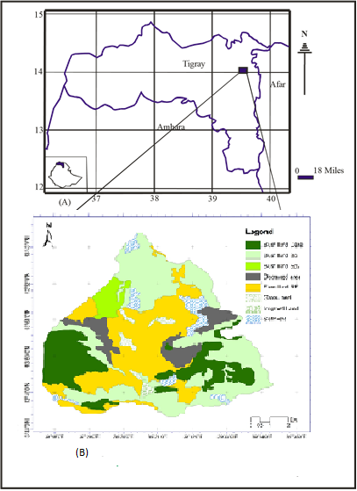
Figure 1 Location map of the study area
Generally, the catchment has dendritic drainage pattern (Fig 1) and the main source of water for the streams is rainfall. The study area is covered by different soil textural groups. Sandy, sandy loam, clay and loamy sand are the main soil types and among these, sand is the dominant textural class. It is found covering the area starting from the upper north part to the lower flat area. In general, the nature, thickness and distribution of the soils varies depending on the slope of the study area: thin soil deposits that are relatively coarse are found on steep slope being deposited along the fractures the rocks whereas thick and fine grained soil deposits are found in the flatland. The land use pattern in the area can be classified in to cultivated land, grazing land, area closure (bush land), home stead and bare land. The cultivated land commonly used for wheat, maize, and others cereal crop production. Currently the farmers use their lands both for cereal crops production and vegetables like cabbage, tomato, chills, onion and fruits by using groundwater as a source for irrigation (Tireza etal., 2013 )

2.2 History of Abraha Atsbaha
The name Abraha-We-Atsbaha is derived from the name of two kings called Abraha and Atsbaha. They were famous in constructing rock hewn churches in Northern Ethiopia, mainly in Tigray. Abraha-We-Atsbaha has 919 households and 5,130 inhabitants its main economic activity is agriculture with dominant local Crops: Maize, Finger millet, Teff, Wheat, Sorghum and Check peas. The community is also known for their white honey product.
The community was producing food for subsistence 15 years ago. The land was drought prone areas, had less fertile soil and low productivity. To solve the problem resettlement was recommended by the regional government as a solution to take the community out of poverty. They worked hard on water and soil conservation not to leave their home village. The community built strong institutional framework which include committees: Watershed committee, Abo-Gereb/Irrigation committee and Development groups to facilitate the development activity in the area. Finally they plan and promote closure areas built 51 micro dams Prepared 519 individual and 144 group hand dug wells Developed 3 springs for human and animal use Produce cash crops and vegetables 2-3 times a year Generate more income to ensure food security at household level Become model community in the region.

Concepts of Integrated Water Resource Management

2.1 Enabling Environment
A proper enabling environment ensures the rights and assets of all stakeholders (individuals as well as public and private sector organizations and companies, women as well as men, the poor as well as the better off, and protects public assets such as intrinsic environmental values. The enabling environment is determined by national, provincial and local policies and legislation that constitute the “rules of the game” and enable all stakeholders to play their respective roles in the development and management of water resources. It also includes the forums and mechanisms, including information and capacity building, created to establish these “rules of the game” and to facilitate and exercise stakeholder participation. Promoting a participatory approach: In order to achieve efficient, equitable and sustainable water management within the IWRM approach, major institutional change is needed. Both top-down and bottom up participation of all stakeholders needs to be promoted - from the national-level down to the catchment or watershed level. Decision-making should be governed by consultation and build on a participatory approach brought down to the lowest appropriate level. Role of civil society: In addition to government agencies and private companies, water development and management should involve NGOs, community-based organizations that have full participation of women and disadvantaged groups, and other sections of civil society. All these organizations and agencies have an important role to play in enhancing access to water, in bringing about a balance between conservation and development, and in treating water as a social and economic good (Apichart A., 2013).

2.1.1 Policies
Setting goals for water use, protection and conservation. Policy development gives an opportunity for setting national objectives for managing water resources and water service delivery within a framework of overall development goals(Apichart A., 2013)..

2.1.2 Legislative framework
The rules to follow to achieve policies and goals. The required water laws cover ownership of water, permits to use (or pollute) it, the transferability of those permits, and customary entitlements. They underpin regulatory norms for e.g. conservation, protection, priorities and conflict management (Apichart A., 2013).

2.1.3 Financing and incentive structures
Allocating financial resources to meet water needs. Water projects tend to be indivisible and capital-intensive, and many countries have major backlog in developing water infrastructure. Countries need innovative financing approaches and appropriate incentives to achieve development goals (Apichart A., 2013).

2.2 Institutional roles
Institutional development is critical to the formulation and implementation of IWRM policies and programs. A number of factors determine what is appropriate in a given context: stage of development, financial and human resources, traditional norms and other specific circumstances. Flawed demarcation of responsibilities between actors, inadequate coordinating mechanisms, jurisdictional gaps or overlaps, and the failure to match responsibilities with authority and capacities for action are major difficulties in implementing an IWRM approach. The agencies involved in water resources management have to be considered in their various geographic settings, taking into account the political structure of the country, the unity of the resource in a basin or aquifer and the role of community organizations and other interest groups in decisions over water use and management. Institutional development is not simply about the creation of formally constituted organizations (e.g. service agencies, authorities or consultative committees). It also involves consideration of a whole range of formal rules and regulations, customs and practices, ideas and information, and interest or community group networks, which together provide the institutional framework or context within which water management actors and other decision-makers operate(Apichart A., 2013).

2.2.1 Creating an organizational framework
Forms and functions. Starting from the concept of reform of institutions for better water governance, the practitioner needs to consider the required organizations and institutions – from transboundary to basin level, and from regulatory bodies, to local authorities and civil society organizations (Apichart A., 2013).

2.2.2 Institutional capacity building
Developing human resources. This includes upgrading the skills and understanding of decision makers, water managers and professionals in all sectors, and undertaking capacity building for regulatory bodies and for empowerment of civil society groups (Apichart A., 2013).

2.3 Management Instruments
Management instruments are the elements and methods that enable and help decision makers to make rational and informed choices between alternative actions. These choices should be based on agreed policies, available resources, environmental impacts and the social and economic consequences. Systems analysis, operations research and management theory offer a wide range of quantitative and qualitative methods. These methods, combined with knowledge of economics, hydrology, hydraulics, environmental sciences, sociology and other disciplines pertinent to the problem in question, help define and evaluate alternative water management options and implementation schemes. The art of IWRM is about knowing the available elements and methods and consequently selecting, adjusting and applying customized tools to the given circumstances. Lessons from the community.

2.3.1 Water resources assessment
Understanding resources and needs. It includes the collection of hydrological, physiographic, demographic and socio-economic data, through setting up systems for routine data assembly and reporting.

2.3.2 Planning
Combining development options, resource use and human interaction. River, aquifer and
Lake Basin planning entail a comprehensive assembly and modeling of data from all relevant
domains. The planning process must recognize social, economic and environmental needs using a
range of assessment tools.

2.3.3 Demand management
Using water more efficiently. Demand management involves the balancing of supply and demand, focusing on the better use of existing water withdrawals or reducing excessive use rather than developing new supplies.

2.3.4 Social change instruments
Encouraging a water-oriented civil society. Information is a powerful tool for changing behavior in the water world, through school curricula, university water courses and professional and mid-career training. Transparency, product labeling and access to information are other key instruments.

2.3.5 Conflict resolution
Managing disputes, ensuring sharing of water. Conflict management has a separate focus as conflict is endemic in the management of water in many places and resolution models must be at hand.

2.3.6 Regulatory instruments
Allocation and water use limits. Regulation in this context covers water quality, service provision, land use and water resource protection. Regulations are key for implementing plans and policies and can fruitfully be combined with economic instruments.

2.3.7 Economic instruments
Using value and prices for efficiency and equity. Economic tools involve the use of prices, subsidies, and other market-based measures to provide incentives to all water users to use water carefully, efficiently and avoid pollution.

2.3.8 Information management and exchange
Improving knowledge for better water management. Data sharing methods and technologies increase stakeholder access to information stored in public domain data banks and effectively complement more traditional methods of public information. Information exchange should be strengthened across sectors to include areas such as environment or tourism that have direct implications for water quantity and quality.

Lessons Learned on Practices of IWRM
The practices on approaches of IWRM for Abraha Atsbaha are discussed based on the theories of the pillars as follow:

3.1 Lessons on Enabling Environment
In the previous chapter on theories of integrated water resource management; policies, financing and incentive structures and legislative frame work are discussed under the enabling environment. For Abraha Atsbaha watershed the overall activities regarding the enabling environment are summarized in this sub chapter.
In Abraha Atsbaha watershed the goals for water use, protection and conservation were put based on the national policy of the government. Before 20 years the farmlands were not suitable for agriculture as it is discussed in the historical background, therefore the government recommend to resettle the community to another place as a choice. The community decide to work on their homeland and put goals on how to use their water and how to conserve their land by electing watershed committee. The watershed committee is responsible on prioritizing activities on the watershed and plan where and when to work on watershed activities.
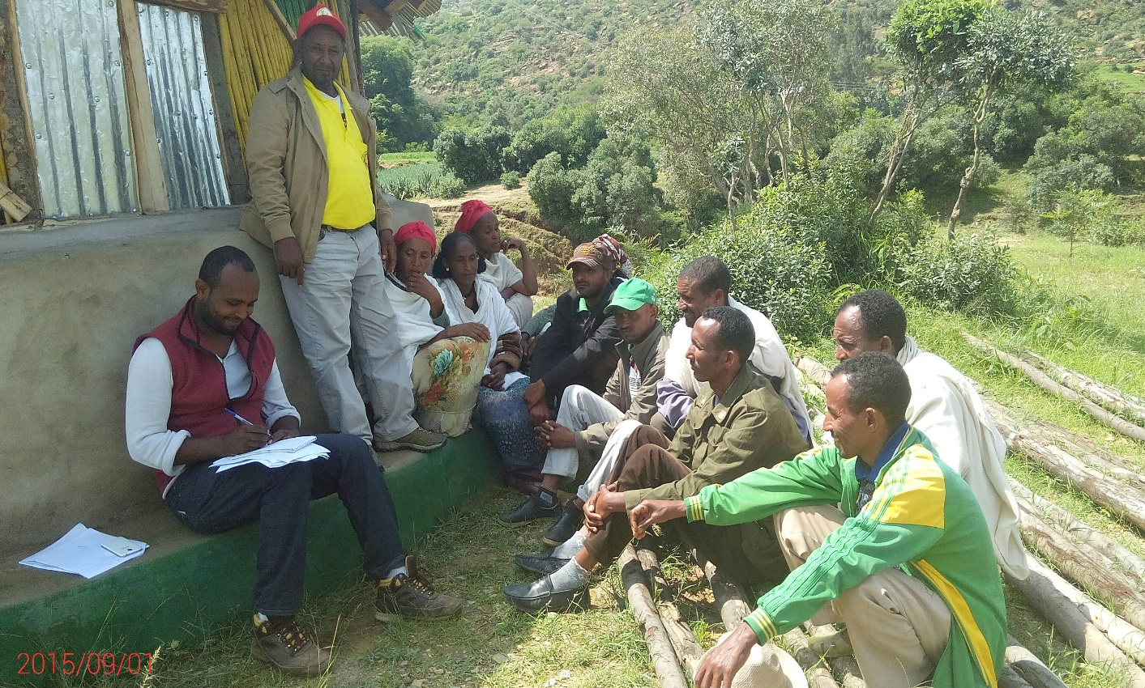
Figure 2 group discussion with community leaders
In Abraha Atsbaha community there are also another seven “Abo Gereb” committees for each “Kushet” which elect by the local Kushet community. The responsibility of Abo Gereb committee is monitoring the overall water use in the Kushet, inform the community when and where to work on the watershed, and solve conflicts on water use discussing with the watershed committee. The Abo Gereb/Irrigation committee has also mandate to mentor the community and facilitate free labor days on the watershed.
To achieve their development goals they work for more than 40 days per year voluntarily for free in the watershed. The government and NGO’s supply materials for activities in the watershed. Gabion, stone, machineries are some of the materials supplied by the government. The community motivates its own model farmers in every season by giving rewards for their hard work.
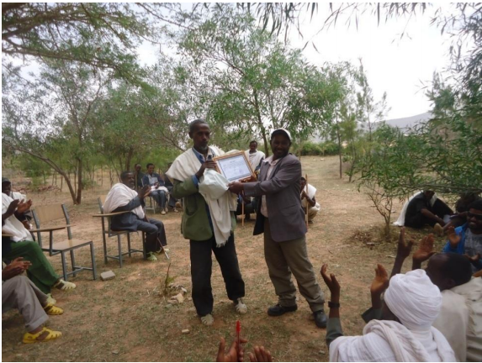
Figure 3community rewards for model farmers

Lessons on Institutional Roles
Creating an organizational frame work and institutional capacity building are the main pillars of institutional roles under the approaches of integrated water resource management. In Abraha Atsbaha watershed as it is shown below in the framework the community leader is elected every five years by the community and the leader select the watershed committee from every Kushet this committee must include women and youth. This selection is finally approved by the people. The mandate of the leader is to bridge the community with the government policies and strategies.
The Abogereb/Irrigation Committee is directly elected by the local Kushet community in their own Kushet. This irrigation committee has six members and is responsible for all water uses in the local Kushet community.
Development Groups are groups of household heads which have five members in one group. Development groups are established based on the location of houses in the Kushet.
Watershed Committee
Community Leader
Abo Gereb/Irr.Committee

Development Groups

Figure 4Local institutional frame work
Developing the human resource and upgrading skills of farmers is the key to realize the development goal in the community. For this purpose in Abraha Atsbaha Woreda there is farmers training center which gives training to farmers on all agricultural activities. Soil and water conservation, livestock production, irrigation water use, beehive, health care and sanitation are areas of the training for farmers in the FTC.
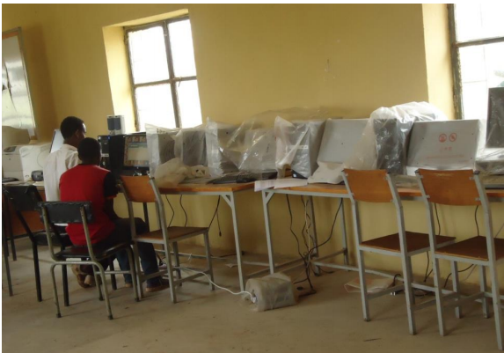
Figure 5 Computer room in the FTC

Lessons on Management Instruments
Water resource assessment, planning, demand management, social change instruments, conflict resolution, regulatory instruments, economic instruments, information management and exchange are described under management instrument pillar on IWRM concepts.
The rainy seasons in Abraha Atsbaha watershed in total have four months whereas the dry seasons comprises of eight months. The mean annual rainfall of the catchment is 565.8 mm, out of which rainy season accounts for 86.13% and the dry season for 13.87%. The rain that occurs with a very high concentration accounts 73.20 % of the mean annual rainfall of the catchment and this occur only in two months (July and August).The mean annual potential and actual evapotranspiration was found to be 832.67 mm and 405.61mm, respectively(Tireza etal., 2013).
The watershed committee plan on the development of their watershed prioritizing works on watershed to conserve soil and water in the area. After constructing soil and water conservation structures in the hill side they construct infiltration ponds at the bottom of the hill sides. Construction of infiltration ponds rises the ground water the community use by excavating hand dug wells. They also construct check dams across the rivers to harvest water and increase their irrigation using the harvested water.
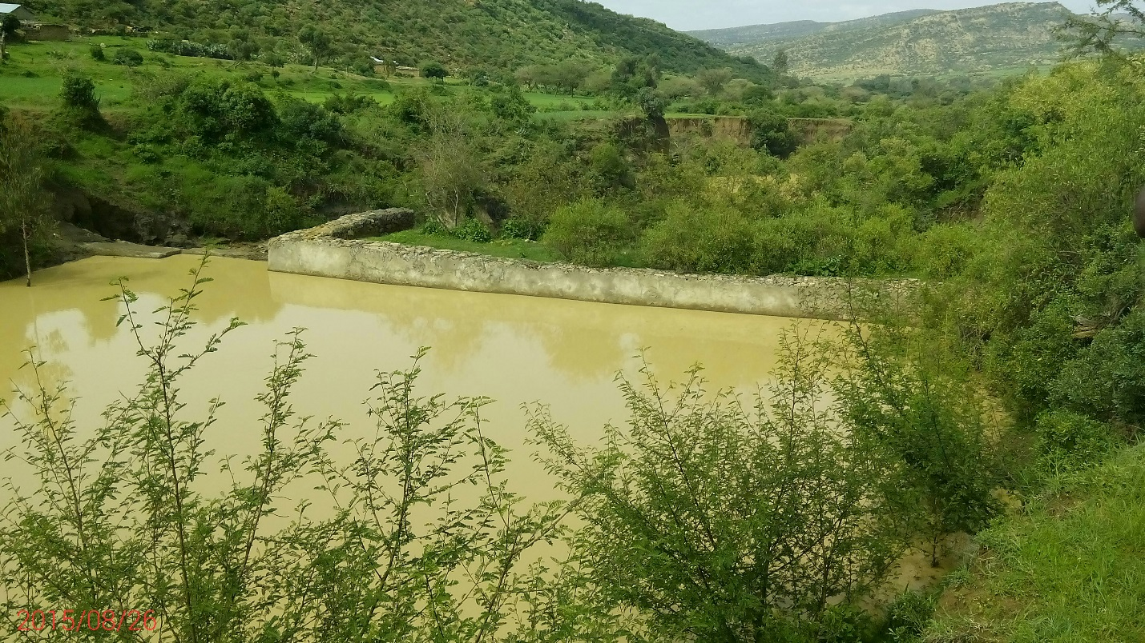
Figure 6 One of the constructed check dams
The Abraha Atsbaha community is oriented based on the water resources located on the nearby to their village homes. This orientation leads for success of their goals by making easy information transfer and integrate development activities.
The community become global equator prize winners of 2012 in Brazil and the chairperson received the award. The community stood one of the top ten out of 800 competitors in the world and won 20,000 USD award and certificate of appreciation.

Conclusion and Recommendation
The case study from Abraha Atsbaha Watershed shows that practicing concepts of IWRM is a long and participatory process. Practicing IWRM needs commitment from the leaders and organized institutional frame work to sustain the development. It also shows participatory multi stakeholder frame work led to the success fullness of the planning and implementation of IWRM.
Farmers from the community recommend having rules in excavating hand dug wells is good for better use. Since there is no rule for excavating drilling many hand dug wells may led to loss of water by evaporation and take much of their irrigation farmlands. Regarding their watering mechanism they also recommend if the government supply them dynamo motor pumps they can produce more.

References
- Apichart Anukularmphai, 2013. Implementing Integrated Water Resources Management based on Thailand’s Experience, Thailand.
- Beatrice Mosello, Roger Calow, Josephine Tucker, Helen Parker, Tena Alamirew, Seifu Kebede, Tesfay Alemseged, Assefa Gudina,,2015. Building Adaptive Water Resources Management in Ethiopia, Addis Ababa, Ethiopia.
- Tireza Nigusse, Eyasu Yazew and Nata Tadesse, 2013. Quantification of the Impact of Integrated Soil and Water Conservation Measures on Groundwater Availability in Mendae Catchment, Abraha We-Atsebaha, eastern Tigray, Ethiopia.
- WB (The World Bank) (2006) World Bank’s 2006 Country Water Resources Assistance Strategy, Ethiopia – Managing Water Resources to Maximize Sustainable Growth. Washington, DC: The World Bank, Washington.
- GWP (Global Water Partnership) (2000) ‘Integrated Water Resources Management’, TAC Background Paper No.4. Stockholm, Sweden: Global Water Partnership – Technical Advisory Committee (GWP-TAC)

