African Veterinary Science Collaborative OER Project Proposal

Introduction
Early in 2015 an opportunity afforded by the generous funding of OER Africa and the Belgium fund enabled veterinary science deans from five African faculties to meet in Pretoria, South Africa to discuss and plan collaborative OER based projects. The discussions centered on the creation and sharing of education resources with the intent of pooling expertise and know-how. The use of open education resources (OER) and digital technologies in particular make collaboration both possible and affordable. The project they conceived aims to elevate the quality of veterinarian education on the continent and this document identifies their approach and collaborative strategies to achieve this vision.

Background to AfriVIP
The collaborative project envisaged by the veterinary deans keys off work already completed by a partnership between the University of Pretoria’s faculty of Veterinarian Science at Onderstepoort and OER Africa. During 2014 this partnership constructed an OER repository of Veterinarian education resources called the African Veterinary Information Portal (AfriVIP). (www.afrivip.org). Currently AfriVIP offers continuing professional development courses for veterinary professionals practicing in South Africa. The faculty is currently working to increase the offerings and broaden the audience of the education portal.

The consortium of regional deans agreed that AfriVIP afforded an opportunity to contribute and share resources. A shared database of quality open teaching and learning materials would allow institutions to organize the resources to work in varied contexts. Consensus of opinion was the more contributors to the shared database the richer the offerings and the wider the potential applications for use. The deans agreed to share the database but called for their own AfriVIP front-end that would be have functionality and branded appropriate to institutional contexts and needs.

Collaborative Partners
These are the founding institutions and deans of the project proposal. It was agreed to grow this list as and when opportunity afforded itself.

University of Pretoria (UP)
Dean: Darrell Abernethy (Darrell.Abernethy@up.ac.za)
Deputy Dean: Linda van Ryneveld (Linda.VanRyneveld@up.ac.za)

University of Namibia (UNAM)
Dean: Prof Japhet Robert Lyaku (jlyaku@unam.na)

University of Zimbabwe (UZ)
Dean: Prof. Davies Mubika Pfukenyi (dpfukas@gmail.com)

Eduardo Mondlane University, Mozambique (UEM)
Dean: Prof. Mario Zefanias Joao Elias (mario.elias@uem.mz)
Associate: Dr. Ana Chimuemue Antonio Malipa (amalipa5@yahoo.com)

Sokoine University of Agriculture, Tanzania (SU)
Dean: Dr. Maulilio John Kipanyula (kipanyula@suanet.ac.tz)
Project leader: Prof. Sharadhuli Iddi Kimera (sikmera@gmail.com)

OER Africa
Director: Catherine Ngugi (catherine.ngugi@oerafrica.org)
Project manager: Andrew Moore (andryn@iafrica.com)

Project Overview
The collaborative project would run over three years (2016-2018) and involve a minimum of 5 African faculties of veterinary science. The teaching and learning products generated by the project would be released with an open Creative Commons license (CC BY) and initially shared using a common database, AfriVIP. The general outcome of the project is to improve the teaching and studying of Veterinary Science in the region through a process of collaboration between African Higher Education institutions.

Student contributions
A common approach agreed on by each consortium member was to use student research as an opportunity to collect and process the OER assets. All five institutions have agreed to devise opportunities for students to collect and record data in the field or hospital that could then be vetted, edited and turned into teaching and learning objects. These objects would then be incorporated into the formal curriculum as well as shared with the wider AfriVIP community. In addition all agreed to repurpose the student OER to support outreach initiatives, such as community messages and farmer education.

Common areas of research
Common subjects for research also emerged, namely Animal Welfare & Ethics, Ethno-Veterinary Medicine (including the identification of indigenous knowledge on animal care) and Farming Systems. Each institution, however, identified areas where they believed they could pool their local expertise. UP, for example, was keen to focus specifically on care for domestic or small animals.

Common need for capacity building
A further commonality identified by all was the need for OER advocacy amongst both staff and students and capacity building, principally amongst student researchers, in the use of digital technologies to capture, edit and store digital assets within a communal database. OER Africa has this expertise and has offered to lead this component of project. However, in order to create a truly collaborative project, where possible expertise from within the academic institutions will be harnessed and shared. To encourage the sharing of expertise it was agreed to set up an online network to encourage communication but also to convene at least twice during the lifespan of the project.

Convening
In order to provide the project participants an opportunity to engage at depth with project issues and share expertise it is anticipated that the participants will meet on at least two occasions. Two representatives from each institution and a representative from OER Africa would meet for a two day meeting where progress and strategic planning could be done to ensure success. It would also be an opportunity to showcase student OER and discuss issues about the database and individual requirements of the institutional front end. Importantly the convening could be used to set up collaborative engagements between the universities in order to share expertise and know-how.
It

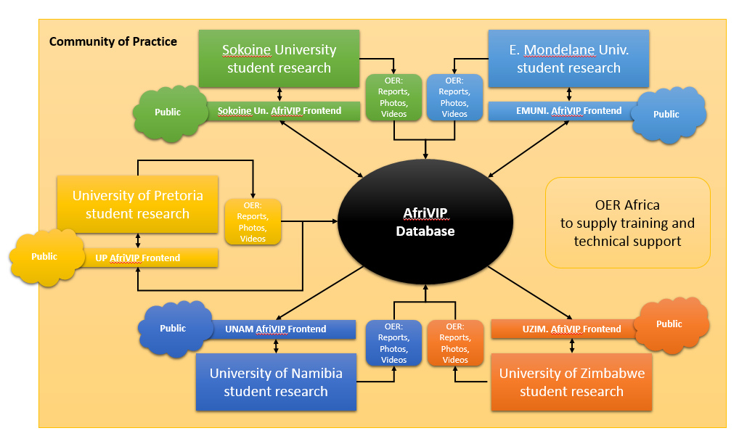
Figure 1: Project Overview

Institutional project activities
Below are the individual institutional project activities:

University of Pretoria, Faculty of Veterinary Science (Onderstepoort)
Insert little overview

Outcomes and Outputs
Identify:
- Outputs: Physical products (e.g. Number of videos, case studies etc.)
- Outcomes: Less tangible impacts (Improved teaching or improved learning)

Activities
In order for the student research project to elicit OER teaching and learning objects the following activities are anticipated at the University of Pretoria, Onderstepoort.
- OER advocacy session for students and departmental staff.
- Student training on use of digital devices to capture, edit and store content.
- Students organized into 12 groups and provided with research brief.
- Organization of student prizes for exemplary work.
- Debate amongst staff to resolve the issue of ethical clearance.
- Students capture hospital and field procedures using digital devices.
- Students edit raw film, provide captioning if voice over in local language etc.
- OER approved or rejected by ethical committee.
- OER uploaded and indexed in AfriVIP
- OER repurposed for additional audiences, e.g. Farmers, community, continuing professional development etc.
- OER showcased at convening meeting.

Budget
Insert Budget

University of Namibia, School of Veterinary Science
The newly formed School of Veterinary Science wants to harness student endeavors to develop OER particularly in the area of Animal Welfare & ethics although they have opportunities to develop teaching and learning assets in the fields of Ethno-veterinary Medicine (including the collection of indigenous knowledge) and farming systems. The output generated by student research in these fields would include fact sheets, brochures and academic papers and presentations. The OER would be packaged appropriately for the different audiences: students, community schools, farmers, the public and even a policy brief for government on animal welfare and ethics.

Outcomes and Outputs
Identify:
- Outputs: Physical products (e.g. Number of videos, case studies etc.)
- Outcomes: Less tangible impacts (Improved teaching or improved learning)

Activities
Activities to achieve these ends include
- OER advocacy for both students and staff at the school (including the capture/collection of digital assets.)
- Student collect data from rural areas and/or local urban communities.
- Student and supervisors analyze data and identify trends.
- Packaging of OER according to audience needs and preferences.
- Upload of the OER assets into AfriVIP database.
- Development of an UNAM OER front end for the AfriVIP database.

Institutional Budget
Includes laptops, smartphones, tablets, dedicated wifi,

University of Zimbabwe (UZ), Faculty of Veterinary Science
UZ reports that students, staff and parents are critical of digital technologies believing them to be inferior to traditional methodologies. They also believe that the local infrastructure is too unreliable to support the successful use of electronic media and tools. Therefore, for an OER digital project to succeed there is a need for a round of advocacy and the identification of alternative methods to ensure access and use of digital content and tools. The project team believes that there will be a need to also update the local infrastructure to support the project, ideally by increasing the coverage of wifi hotspots and the purchase of a few digital cameras.

They believe advocacy should be aimed at years 1-5 and should include technical training so that they can support and maintain their own interface for the AfriVIP database. The student research, designed to develop OER, will be in the area of animal welfare and ethics as well as Ethno-veterinary medicine, and disease cases.

Outcomes and Outputs
Identify:
- Outputs: Physical products (e.g. Number of videos, case studies etc.)
- Outcomes: Less tangible impacts (Improved teaching or improved learning)

Activities
Activities to achieve these ends include
- Advocacy for students and staff at the university that covers OER, eLearning and Lo-fi strategies to take advantage of technology.
- Devise student project built into the curriculum to OER.
- Student collect data from rural areas and/or local urban communities.
- Student and supervisors analyze data and identify trends.
- Upload of the OER assets into AfriVIP database.
- Development of an UZ OER front end for the AfriVIP database.

Institutional Budget
Includes. Wifi, digital cameras, tablets,

Universidade Eduardo Mondlane (UEM), Faculty of Veterinary Science (Mozambique)
It is envisaged that the OER project will use students to collect data from Mozambique’s interior and northern regions. Eduardo Mondlane University’s Faculty of Veterinary Science wants to uses prizes to reward innovative work and the collection of unique case studies. The focus of the data collection process will be on gathering interesting Veterinary cases, animal welfare, medical ethics and also the collection of indigenous knowledge on animal care.

Outcomes and Outputs
Identify:
- Outputs: Physical products (e.g. Number of videos, case studies etc.)
- Outcomes: Less tangible impacts (Improved teaching or improved learning)

Activities
Activities required to achieve the collection and sharing of this data
- OER advocacy and training of students and lecturers in the collection of data using digital devices. It is suggested that they understand also the role that educational technology is playing in transforming higher education (e.g. MOOCS, OER, etc.). For under graduate sessions the language of instruction is Portuguese but increasingly post graduate training can be in English.
- Organize trips to canvas farming communities or vets operating in rural communities. In keeping with indigenous knowledge data collection techniques they should spend some time in these communities to elicit trust.
- Students and lectures analyze and process the collected data.
- This data is uploaded and indexed to AfriVIP (including Portuguese language assets.)
- Prizes awarded to exemplary contributions.
- Portuguese front end designed for Eduardo Mondlane Veternary faculty’s access to AfriVIP.

Budget
Includes
Hardware: 5 laptops, 5 smart phones, wifi, 5 memory sticks, 2 PCs and 5 external drives.
Travel: 5 bus and airplane trips into interior.
Prizes: 5 prizes

Sokoine University (SU), Faculty of Veterinary Science (Tanzania)
SU’s focus for student research is in the fields of Production Systems, Indigenous Knowledge, Animal Welfare and Ethics and the collection of important case studies and events. A requirement, however, is to train them to filter information, repackage data for different audiences and the preparation of community messages, OER preparation and distribution. It is envisaged that these community messages will be incorporated as additional outreach activities for the students and staff.

Outcomes and Outputs
Identify:
- Outputs: Physical products (e.g. Number of videos, case studies etc.)
- Outcomes: Less tangible impacts (Improved teaching or improved learning)

Activities
Insert here

Budget
Mini-server, 20 computer lab, network printer, wireless hotspots, digital cameras, GPS, video editing software, 5 laptops, data projector, memory sticks, travel, prizes.

Project coordination and governance
OER Africa is an initiative of the South African institute for Distance Education (Saide). It is proposed that SAIDE coordinate the 5 institutions and coordinate their funding.

Budgets
The first budget is a for the entire project covering costs of the actives at all five institutions. The following budgets are based on individual institutional requirements to fund their project commitments.

Total budget
Budget here

Institutional budget contributions

UP Budget
Budget here

UNAM budget
Budget here

UZ budget
Budget here

EMU budget
Budget here

SU budget
Budget here

Conclusion
Conclusion here

