Origin and purpose of the project
Since its inception, SAIDE has been concerned to widen access to education of good quality through the use of distance education methods, key to which is the provision of high quality course materials. The teacher education project described in this article was designed to support South African higher education institutions respond to the large scale teacher upgrading and development needs in the country in a quality way.
The project gives expression to a proposed strategy for developing quality learning resources described in the distance education policy research undertaken by SAIDE on behalf of the Council on Higher Education in 2003/4, Enhancing the Contribution of Distance Higher Education in South Africa. The proposed strategy builds on the notion of ‘national network of centres of innovation in course design and development’ advocated in the White Paper (DoE, 1997: 27). It describes this network as follows:
A network of virtual centres of innovation in course design and development, consisting of contributing providers organized into teams for the development and sharing of learning resources in response to specific needs and loosely coordinated as a network. (Council on Higher Education, 2004: 161)
In the ACEMaths project, SAIDE set up and coordinated the work of a ‘virtual centre for innovation in teacher education course design and development’. A team of mathematics teacher educators based at different institutions engaged in a collaborative process for the selection, adaptation and use of materials.
The various titles of the project indicate how it evolved from when it was first considered in 2006:
- Proposal to support the national initiative for the upgrading of teachers through the Advanced Certificate in Education (May 2006).
- Proposal for a collective open educational resources initiative in the design and delivery of Advanced Certificate in Education programmes (July 2006).
- A collective open educational resources initiative in the design and delivery of modules for Advanced Certificate Programmes (October 2006).
- One to many: a collective approach to adapting a maths teaching and learning module for a variety of programmes – the ACEMaths project (May 2007).
- Developing and using open educational resources - the SAIDE ACEMaths project and OER Africa (title of the workshop presented in September 2008).
As is apparent from the phrases in these titles, the project did not aim to develop materials from scratch but instead encouraged institutions to share existing materials and collaborate in adapting them. In the beginning, the intention was to develop a whole programme (a teacher upgrading programme leading to an Advanced Certificate in Education), but as the project evolved, it was clear that it would be better to spend limited time and resources developing a single module in a key curriculum area that could be adapted for different programmes.
In addition, when the project was being developed, there were changes in the global environment which could not be ignored – in particular, the increasing prominence of Open Educational Resources. SAIDE conceptualized the project in the Open Educational Resources environment not because it was fashionable, but because of the clear resonance between our project aims and the purpose and advantages of Open Educational Resources (OERs).
Our understanding of OERs is that they are educational resources which are freely available on the web for use by any number of people. The resources can be end products; that is, freely available content, teaching material or research. But they can also be the means to an end; that is, the software that facilitates materials development and/or the actual process of collaborative development of material though interaction in an environment that has been set up to allow for the development of materials. The ‘free’ availability does not necessarily mean ‘free of cost’. The freedom may simply be in the ease of access, made possible both by the Internet and the freer licenses under which materials are released.
There is not one definition of OERs, though many writers use the one adopted by UNESCO:
the open provision of educational resources, enabled by information and communication technologies, for consultation, use and adaptation by a community of users for non-commercial purposes (Albright, 2005).
Another definition given by Jan Hylén (of OECD/CERI) as ‘the most commonly used definition of OER’ is:
Open Educational Resources are digitised materials offered freely and openly for educators, students and self-learners to use and re-use for teaching, learning and research. (Hylén, 2006: 2)
‘Re-use’ and adaptation are key in both these definitions. But Jan Hylen also points out that although Open Educational Resources are primarily materials, they can also be tools (such as licenses, or instructional design templates). In addition, the digital environment of OERs can be used to facilitate communication and collaboration in the broader educational enterprise. The notion of ‘communities of practice’ as developed by Etienne Wenger assumes prominence in OER environments.
In a field such as teacher education in South Africa, SAIDE is interested in the potential of OER practices to energise not only individual academics or single institutions, but also the provision of teacher education across the system.
Figure 1: The OER ‘hand’
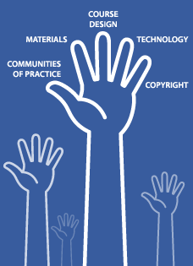
From the first workshop held to form the team of teacher educators for our ‘virtual centre’, we used the metaphor of the hand (Figure 1) both to locate the project in the OER environment and to structure our continuing research of that environment. In our view, an OER project has to be concerned not only with the materials/resources, but the courses in which these materials are used. Materials need to be as freely available as possible – and hence copyright/licensing issues need to be explored and attended to. However, while materials may be released under licences which make them more easily available to more people than under conventional copyright, this does not necessarily mean that they will be used in an open and creative way. To deserve the title of an OER initiative, a project should deliberately set out to create and sustain a community of practice amongst people who will contribute to, use and adapt the resources that are developed. In a digital environment, this will involve considerations of how technology can be used not only as a repository for the resources but also to support ongoing resource adaptation and development through the community of practice.
With this broad framework as a basis, we called for volunteers from the 23 higher education institutions in South Africa to decide on a focus area for materials selection and adaptation and form the first community of practice. Amongst the thirteen institutions that came to the first meeting, we found that primary school mathematics was a common upgrading specialization. In addition, however, two institutions were involved in upgrading qualifications in the area of Inclusive Education/Special Education/Education of Learners with Barriers to Learning. The decision was therefore to focus our work on a combination of these two interests.

Figure 2: Cover page for Unit One
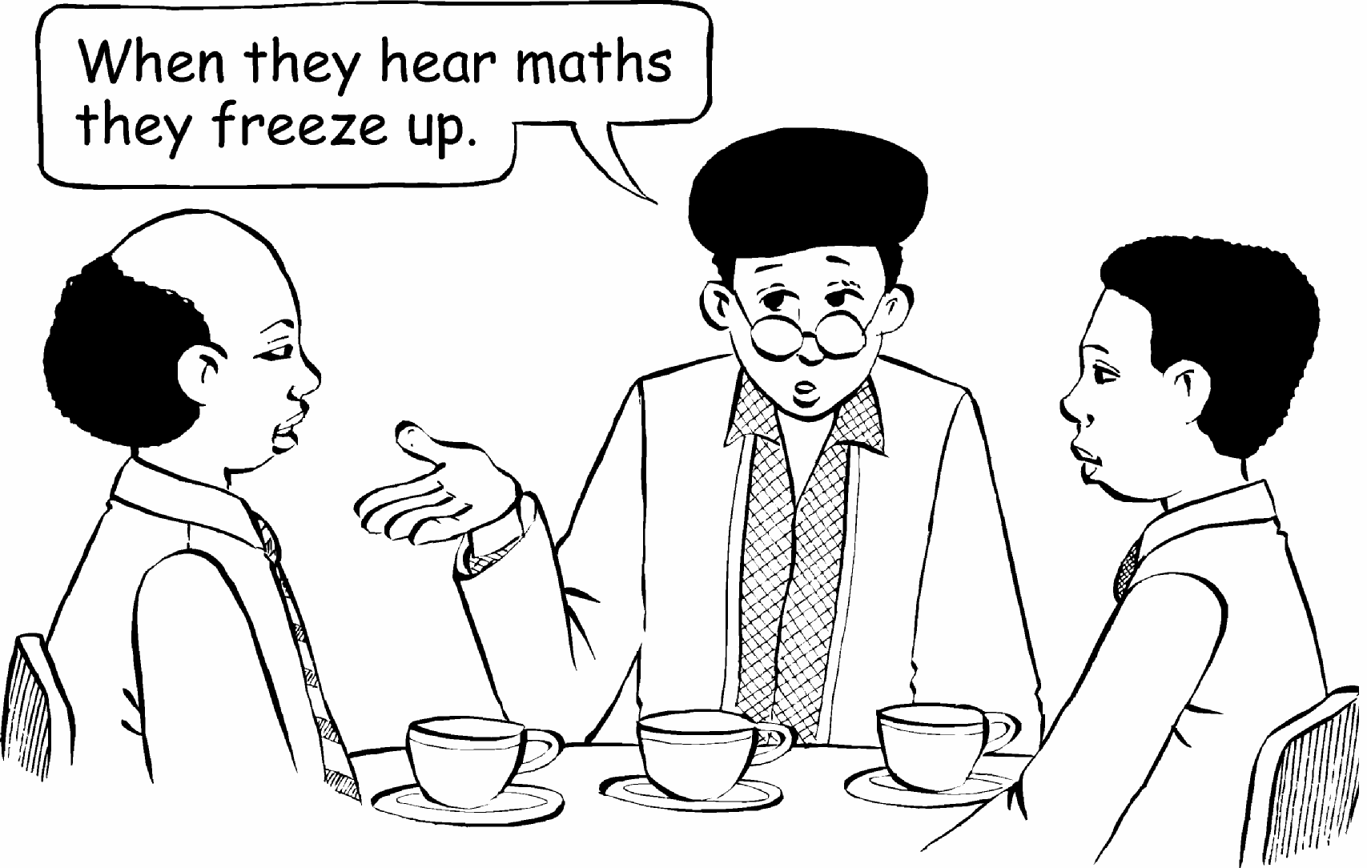
The six unit module produced through the process is entitled Teaching and Learning Mathematics in Diverse Classrooms. It is intended as a guide to teaching mathematics for in-service teachers in primary schools, is informed by the South African inclusive education policy (Education White Paper 6 Special Needs Education, 2001) and supports teachers in dealing with the diversity of learners in South African classrooms. In a variety of ways, it addresses the challenge expressed by teachers in Figure 2.
The module team consisted of 12 teacher educators involved in mathematics teacher education from eight institutions. Seven institutions stayed the course of the two year project, and six participated in the pilot of the first draft of the adapted materials in 2007. All six institutions continue to use the revised materials the following year, as well as in 2009 after the close of the project.

Testing the principles that guided the pilot
The project was underpinned by a number of principles derived from previous SAIDE experience in programme and materials development projects. This section describes briefly the rationale for each principle, what happened in the pilot, and lessons of experience.

1. Find existing ‘good enough’ materials and adapt these for immediate use.
Rationale: Development of materials from scratch requires a lead time of 12 to 24 months, but very few materials development initiatives have the luxury of this timeframe. However, there are a number of institutions/organizations that have ‘good enough’ existing materials, and the time involved in adapting/customising them for the context and programme purpose will be less than that involved in developing them from scratch. In addition, the focus should be on use, rather than on preparation of an ‘ideal’ set of materials, as it is through use that the strengths and weaknesses of materials are discovered, rather than from de-contextualised reflection on instructional design, although judicious use of expert review is helpful.
What happened in the pilot: After reviewing available materials in South Africa, workshopping a curriculum document to guide the adaptation, and, in particular the inclusive education focus, the team selected a UNISA module called Learning and Teaching of Intermediate and Senior Mathematics to work with. The main reasons for selecting this module were: theoretical alignment with the prevailing view of mathematics teacher education in the group as well as comprehensiveness of coverage. The fact that this module was already designed for self-instruction was also a factor in the selection. In addition, team members could easily see how activities and supplementary material from their institutions could be integrated into the UNISA material.
Lessons of experience: The materials are being used for a third time by participating institutions, so the final product is clearly useful. However, they were less easy and more time-consuming to adapt than assumed at first. The reasons for this include: size of resource (the final adapted units plus additional readings amount to 350 pages) unevenness in quality of writing in the UNISA text, but mainly, over-reliance of the original text on a single (albeit good) textbook from the United States with insufficient adaptation for the South African context.
What was not fully realised at the outset was that combination of two content areas – maths teaching and learning, and inclusive education – made the module, and particularly the final unit, unique. This has contributed to its continued usefulness. In other words, it is helpful to plan the adaptation with at least in part a new angle on the subject matter, so that it is not simply re-doing what is already there.

2. Identify a single module that can be adapted and used in a variety of programmes, rather than setting out to develop a whole programme.
Rationale: This is advisable for three reasons. One is that it is more cost-effective, but the second is that institutions are responsible for the development of their own programmes, and there is correctly resistance to a pre-packaged received curriculum, even if that curriculum is determined by and with respected peers. A single module, on the other hand, is perceived as a resource, rather than a blue print for delivery. Finally, institutional processes for the approval of new programmes take a minimum of a year, whereas academics can easily insert a new material into a single existing module, or in place of module with the same/similar outcomes. This is a major consideration in an environment that requires responsiveness.
What happened in the pilot: Uptake in the pilot was extremely varied, with six institutions using the materials for in-service and pre-service teacher education, in maths teaching and learning courses, as well as in inclusive education programmes. The materials are now being used for the third successive year by participating institutions, and the number of students as well as the range of programmes using the materials has increased each year.
Lessons of experience: The single module approach worked for most participating institutions. However, for one institution, a single module was not enough because there was no upgrading programme into which to slot the module. They needed support in the development of a whole programme, which the project did not have the time or the funds to provide.

3. Keep costs/time down but maintain quality.
Rationale: A key aim of this project was to make it possible for institutions to respond quickly to departmental needs for large scale teacher upgrading without having to resort either to recirculation of existing often poor quality material, or to commissioning of new material in timeframes which make it impossible to achieve quality.
What happened in the pilot process: The writing time needed for the adaptation process was longer than originally planned, particularly as it became clear that the final unit which tied together the inclusive education and mathematics focus of the module would have to be written from scratch. The original estimates were that the adaptation would require a light touch and we set aside 9 days for the SAIDE project leader, and 7 days for the contracted content expert to prepare the adapted materials for the pilot version. In practice, 18 days and 16 days were needed respectively. Even though the adaptation work required was more extensive than originally envisaged, a pilot version of the adapted version was ready 6 months after the inception of the project, with a variety of quality checks built into the process. The following diagram shows the process followed.

Figure 3: Six month process to produce the pilot version
In the second phase of the project – preparing the revised version in the light of the pilot experience - we were able to reduce substantially the cost and time spent on design by using an Open Educational Resource tool, the instructional design template developed by the Commonwealth of Learning (COL). This template is available free of charge for downloading and adapting on an Attribution ShareAlike Creative Commons licence on the COL website: It took a day to learn how to use this template and customise it for the ACEMaths units. And it took five days to place the revised version of the 350 pages into the template, reading for posting on the OER Africa website. The final units set in the COL template and enhanced by a continuous case study locating the units in the experience of a group of teachers as well as six commissioned illustration of conversations between these teachers are both accessible and attractive.
Lessons of experience: Even though adapting existing materials is less time-consuming than working from scratch, the time required must not be underestimated, particularly for the project leader and key content expert. Adaptation is a process of re-creation rather than merely of revision.

4. Use a team approach in planning the adaptation process, but contract a content expert from the group to do the writing and content specific coordination.
Rationale: If institutions work together and agree to share materials and approaches, not only will the time involved in adaptation be reduced, but the opportunity for learning from sharing of resources will be maximised. The goal in a project of this kind is not only to get a good product, but to engage teacher educators in discussions about what is good. The investment cannot only be in materials; it must be in the people actually teaching teachers day by day. The ‘community of practice’ needs a champion, however, that can direct the process from a position of disciplinary strength. The time investment for such a person is too great to expect that it is done in a voluntary capacity – particularly if there is an urgency to get materials produced.
What happened in the pilot: SAIDE contracted one of the team, Ingrid Sapire, from the RADMASTE centre at Wits University as content leader of the process. The team was inter-institutional – with 12 participants drawn from eight different institutions. The team was brought together at the SAIDE offices for three workshops to develop the curriculum, select the core materials, and workshop an approach to the development of the final unit. After the completion of the pilot, the team came together for a final workshop to make decisions about how to revise the materials in the light of the pilot experiences as well as input from a critical reader.
Lessons of experience: Ingrid Sapire’s maths teaching and materials development experience not only gave professional credibility to the project, but her maths teacher education network facilitated the selection of the UNISA materials for adaptation, the incorporation of additional materials from other sources, as well as the appointment of editors with maths experience to review the work.
At the end of the process, team members commented that a team of between 10 and 14 members, drawn from different institutions, and held together through funded face to face workshops made the work not only possible, but enriching. They were appreciative of the ‘time-out’ provided in the workshops for focused professional conversations about maths teaching.
A further lesson of experience was that it was asserted from the first workshop that participation in the team (and hence funding of attendance at workshops) required that participants use the adapted materials in a programme they were currently offering. This created the motivation for engaged participation and sharing of professional expertise.

5. Appoint a coordinating agency to manage the process, ensure that the team is built into a community of practice, and that its work culminates in a usable product.
Rationale: It takes time, money and a solid organizational base to coordinate a process – to identify and select materials, to build a team, to manage the process efficiently, and to take leadership in respect of the strategic direction the project should take. It is advantageous for this be done by an agency that is not in competition with implementing institutions for revenue from student fees.
What happened in the pilot: SAIDE led and managed the process with funds from the Royal Netherlands Embassy, who were flexible enough to stay with the project as it moved through different phases.
Lessons of experience: What was learned in this process endorsed the insights from Etienne Wenger into how a community of practice works. The participating institutions supported/sponsored the involvement of maths teacher educators from their institution in the team; there was funding for the project from the Royal Netherlands Embassy; the community was nurtured both by dedicated content expert time and by a project leader from SAIDE; and it was supported by the SAIDE infrastructure and later, the technical expertise of the OER Africa team. In other words, a community of practice needs a clear domain with relevant participation from active practitioners in the field/domain. But this is not all that is necessary. It needs nurturing from within, as well as sponsorship and support from without.
Figure 4: How a community of practice works
Source: Presentation given by Etienne Wenger entitled Social discipline of learning – key dimensions, at the Third Annual NQF Colloquium, Pretoria, 5 June 2007.

6. Encourage institutions and authors to make their materials available under a Creative Commons BY SA licence, but do not make this a pre-condition for contribution.
Rationale: Intellectual property is a complex terrain, and the Open Educational Resources movement is challenging conventional notions in ways that many academics and institutions find threatening. There are some hardline OER proponents who argue for no compromise on the use of open source software and non-proprietary operating systems as well as particular licenses. However, the approach taken in this project is that the major goal is to increase openness and accessibility of educational resources, and any move towards greater openness should be supported. Hence, although our research indicates that the best licence for OERs is one of the Creative Commons BY-SA licenses (that require only attribution/acknowledgement of the author and sharing of the materials in the same way as they have been made available), this is not insisted upon.
What happened in the pilot: The two main institutions involved were UNISA and the University of the Witwatersrand. The process of obtaining permission from UNISA involved a meeting with senior people, a telephone discussion with the UNISA legal officer, and two versions of a letter of permission – in total a day’s work over a period of 6 weeks. It was important to hold to the principle of respecting the limitations that UNISA wished to place and finding a Creative Commons license to accommodate this. The achievement in the negotiations with UNISA was significant - although UNISA retained copyright on the original version of the module, SAIDE was granted the right to re-license the adapted version in whatever way they felt best. The process of obtaining permission from the University of Witwatersrand extended over eighteen months, but the total time spent on negotiating it was less than half a day.
Lesson of experience: The pilot demonstrated that while it is possible with a little effort to negotiate with institutions for the release of existing materials for adaptation under more open licenses, the release of the original version of the materials would have been more problematic.

7. Don’t foreground technology or make it a sine qua non for participation – but stay in touch with new processes and tools that can enhance collaboration and increase efficiency.
Rationale: The concept of OERs is currently associated almost exclusively with electronic educational resources. However, the ‘openness’ or free accessibility of educational resources is not logically associated with their being available in electronic format, or developed using digital tools. The goal is not technological literacy, the goal is increased openness and the development, of an educational commons through collective effort. Sometimes so much energy is spent on understanding and using the technology that there is little energy and time left for developing high quality materials and courses. A collective effort may therefore not in the first instance be digitally facilitated, although to realise its full potential for access, digital formats and processes are necessary.
What happened in the pilot: When the project started, SAIDE was still exploring an appropriate technological platform for the materials. When the pilot version of the materials was ready, they were posted unit by unit on a dedicated web page associated with the SAIDE website. Team members were given usernames and pass words to access the materials to download for printing and adaptation for the pilot in 2007. However, there was relatively little use of the website – team members preferred working with the paper versions distributed at the workshops.
When the revised version was ready in mid 2008, the OER Africa initiative had just been launched, and was under SAIDE management.

Figure 5: OER Africa
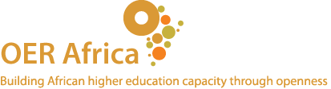
www.oerafrica.org
OER Africa aims to create and sustain human networks of collaboration, face-to-face and online, in order to enable African academics to harness the power of OER, develop their capacity, and become integrated into the emerging global OER networks as active participants rather than passive consumers.
The underpinning principles and resources available from the ACEMaths project were clearly aligned with these aims, and so the ACEMaths community became one of the first communities featured on OER Africa. SAIDE worked with the OER Africa team to design the site not only as a repository for the six unit module, but also as a place in which conversations can happen around the materials and the various adaptation of the materials. Case studies of adaptation were posted on the site, with a blog facility to allow for comment and engagement by interested parties. A Forum page was also created – and the conversation started with input from the Maths teacher education expert, Jill Adler, the critical reader for the pilot version of the materials. We also thought it was important to make the site a repository for project documents – reports, presentations, but also key research papers that inform the project as an OER initiative – papers on the Open Educational Resources movement, on course design in an OER environment, on copyright and licensing, on materials development, on communities of practice. The site can be viewed at:
http://www.oerafrica.org/Communities/ACEMathematics_Home.aspx
However, although people might be looking at the website, there is at this stage, no evidence of ongoing engagement. To stimulate knowledge of the site and materials, SAIDE is now visiting institutions and holding workshops with teacher educators. To facilitate use of the materials for people with low bandwidth or irregular internet connectivity a CDROM has been created containing the module materials as well as the project documents.
Lessons of experience: The position that is emerging as SAIDE staff engage with projects such as ACEMaths can be found in an article on the ACEMaths website: On OERs: Five ideas to guide engagement with the Open Educational Resources ‘movement’ (Welch, 2008). One sentence from this article will suffice to encapsulate the lesson of experience from ACEMaths project:
Exclusion not only from but through technology is very easy. The role of educators is to ensure that this exclusion is minimised. We need to understand enough about the technology to be aware of how it is being used to serve the purposes of educational exclusion, and insist that it be used to serve the interests of inclusion.

