An OER protocol
Guidelines for publishing Teacher Education OER

Draft for comment

September 2012

An OER Protocol
Guidelines for publishing Teacher Education OER
Draft for comment and/or adaptation

This work is licensed under the Creative Commons Attribution 3.0 Unported License. To view a copy of this license, visit http://creativecommons.org/licenses/by/3.0/.
© South African Institute for Distance Education

Based on: Version 6: 21 April 2011, Recommended Practices for Packaging and Distributing OER
© 2011 Regents of the University of Michigan and Saide.
Creative Commons Attribution 3.0 License

Table of contents

Introduction 1
Section One: Copyright and licensing 1
The difference between copyright and licensing 1
Guideline 1: Clarify who owns the copyright in works produced with the funded money 1
Selecting a license 2
Guideline 2: Select the most open Creative Commons license you can 2
Identifying information on each resource 2
Guideline 3: Ensure that the OER has the necessary reference details visibly displayed 2
A note on citation and attribution 4
Guideline 4: Specify how the material is to be cited when other people reuse or adapt it 4
Guideline 5: Attribute correctly any content objects included in the OER that have been created by someone other than authors 4
Third party copyright clearance 5
Guideline 6: Ensure that permission has been obtained for third party copyrighted material used in the material 5
Ethical clearance 6
Guideline 7: Prior to the use of photographs and videos containing recognisable people, obtain ethical clearance 6
Section Two: File formats 6
Selection of file formats 6
Guideline 8: To facilitate adaptation, use formats for text, images, video and audio that are commonly used and editable 6
Preparation of files for uploading 7
Guideline 9: Prepare the material for uploading with a view to ease of downloading, remixing and discoverability 7
Section Three: Metadata 8
Guideline 10: When a resource is submitted for uploading, the institution/s should provide the necessary metadata – particularly title, description, and key words 8
Section Four: Quality management 10
A note on tracking and describing use 11
Activity 1: Introduction 13
Activity 2: Section One 13
Activity 3: Section Two 13
Activity 4: Section Three 13
Activity 5: Section Four 14

List of Figures
Fig 1: The relative openness of Creative Commons licenses 2
Fig 2: Imprint page from a Saide module 3
Fig 3: Attribution of illustration 4
Fig 4: Attribution of ‘chunked’ section of audio 7
Fig 5: Making OER available in different formats (see OpenLearn) 8

Foreword
The first version of this Protocol was developed by Saide for the Department of Higher Education and Training (DHET) based on work done for OER Africa’s Health OER Network, as well as experience in digitising and uploading the Saide Teacher Education series (see www.oerafrica.org/teachered). DHET has put in place a European Union funded Strengthening Foundation Phase Teacher Education Programme. In terms of the contract with the institutions participating in the programme, all materials produced will be released as Open Educational Resources (OER). This will facilitate sharing across institutions, improvement of quality through peer review processes, and ensure that materials developed with public money are made available as widely as possible. The purpose of the Protocol is to guide the Department in managing the publication of these materials as OER on their Teaching Development website.
We thought that there was merit, however, not only in a DHET specific Protocol, but a generic version that institutions could customise/version for OER publishing of teacher education materials produced at or through their institution. Although primarily intended for teacher education OER, we tested this idea in an OER workshop with a team of librarians, IT specialists and academics involved in produced a Food Safety course at the University of Cape Coast in Ghana. As one of the appendices to the Protocol, we attach the Workshop activity on the Protocol that we used.
The response to the process from the teacher education institutions in South Africa was enthusiastic, and so we offer this Protocol and set of guidelines for you to comment on and/or customise/version for your needs in your institution.
Although, in terms of the Creative Commons Attribution license, you don’t have to ask our permission to adapt, copy, distribute, the Protocol, we would really appreciate it if you would give us feedback on what you think of it and how you may use it. We’d also love to feature your versions of the Protocol on the OER Africa website.
Tessa Welch and Sheila Drew
Acknowledgements
All Saide education staff have been involved in commenting on this draft document. However, in particular, we wish to acknowledge Jenny Louw, Saide’s Information Services manager, and Monge Tlaka, the website and OER publishing manager for OER Africa, for their work that provided (and continues to provide) the basis for this Protocol.

Introduction
This Protocol and set of guidelines is intended to support an institution or organisation in managing resources that will be released as Open Education Resources (OER), which are
educational resources (including curriculum maps, course materials, textbooks, streaming videos, multimedia applications, podcasts, and any other materials that have been designed for use in teaching and learning) that are openly available for use by educators and students, without an need to pay royalties or licence fees.
OER may be distributed in a variety of formats, including electronically online, removable media (e.g. CD/DVD, or USB), and/or paper hard copies. In order to maximize its reach and visibility, OER is often distributed online which introduces new considerations such as managing file size and selecting appropriate descriptive data (commonly referred to as metadata). File size and structure is an especially important consideration as small manageable files can be more easily downloaded in bandwidth-constrained areas.
The aim of this Protocol is to support the creation of OER that is easily discoverable, accessible, and adaptable.

Section One: Copyright and licensing

The difference between copyright and licensing

Guideline 1: Clarify who owns the copyright in works produced with the funded money
A distinction needs to be made between copyright and licensing. The institution or organisation that hosts the resources on a website is the publisher of the materials. Copyright is a form of legal protection that allows authors, photographers, composers, and other creators to control some rights in the reproduction and distribution of their work. They can assign some or all of their rights to other agencies, such as publishers. But, unless they have ceded their copyright in its entirety, they are still the owner of the work. There has to be clarity about who owns the copyright in the materials that authors hired by an institution or organisation create in the course of their employ.
In most institutions or organisations, the position is that intellectual property rights of work produced reside with the institution, and is shown, for example:
© University of the Witwatersrand
As copyright holder, the institution determines how to cite the work, and, for purposes of publishing resources as OER, needs to agree to the Creative Commons license selected for the release of the work.
In cases in which the policy is not clear, it is recommended that the institution retain the copyright in such works.

Selecting a license

Guideline 2: Select the most open Creative Commons license you can
The most commonly used open licenses are those designed by Creative Commons. At http://creativecommons.org/choose/ you will find the main questions that will guide you in the selection of a Creative Commons licence. These are:
- Do you wish to allow modifications of your work?
- Do you wish to allow commercial uses of your work?
The point of an open license is to remove unnecessary barriers to the use of your work – so it’s advisable to choose the most open license you can. The following diagram is helpful – see http://scottfisk.com/design/use-creative-commons/, as it illustrates the most open (green thumbs up) and least open licenses (red thumbs down).
Fig 1: The relative openness of Creative Commons licenses
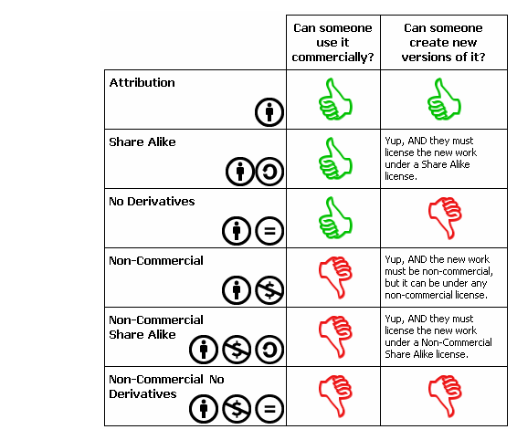

Identifying information on each resource

Guideline 3: Ensure that the OER has the necessary reference details visibly displayed
All published resources should contain the following information with the downloadable version:
- The Creative Commons license with hyperlink to the license
- The name of the Copyright Holder and Year of Publication
- The name of author(s) (N.B., this may be different from the copyright holder)
- Branding of the institution/s, associates, funders etc.
- Acknowledgements of those who contributed (media specialists, voiceovers, collaborators, etc.)
- List of all third party copyright clearance obtained (title of resource with copyright holder – see below for more detail)
- How the OER is to be cited.
- General contact person – an email address for managing inquires about the OER.
For print-based (for example, in Word, PowerPoint, PDF) materials:
Include the above information on the first and last pages of the resource, or alternatively on the imprint page. For example,
Fig 2: Imprint page from a Saide module
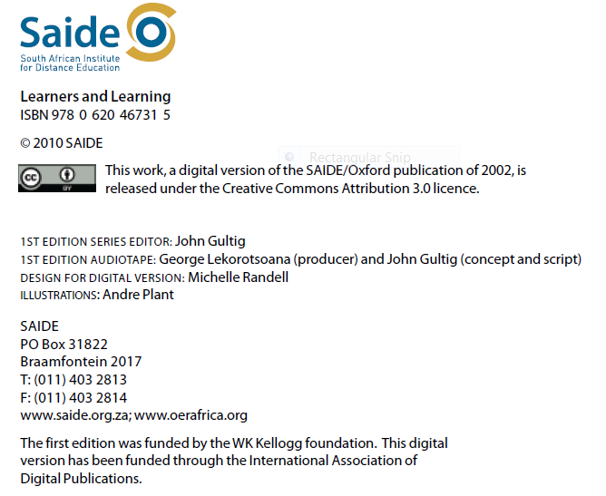
In addition to the information being presented on the title page/imprint page, it is recommended that attribution information be placed in a header and/or footer on every page. This is because there is a chance that a document may be cut up into smaller segments as it is distributed (this is especially true for large documents or materials that has several chapters).
For videos:
- Include a ‘video bumper’ or a still picture at the beginning or end of the video. This should include full referencing for the resource, including the author, year of production, title of resource, name of faculty, name and logo of institution, CC licensing with appropriate URL etc (same information outlined for Word, PDF and PPT documents above).Go to the CC website to download sample bumpers.
- At the end of video, the ‘video bumper’ can include a list of credits as well as the information appearing in the still picture (in the event that the resource is cut up into segments).
- Additional information indicating attribution such as the Institutional logo can also be added on the right hand corner throughout the video.
- Include a transcript or story board of the video in either Word or PowerPoint.
For audio resources:
- When introducing the resource, read into the script the details of attribution and licensing.
- If the audio files are located on the Internet include the attribution and licence details with a description/link to the resource.
- Include a transcript or story board of the video in either Word or PowerPoint.
For images:
- The CC licence used with a hyperlink or the icon for licence.
- Name of the contributor/photographer.
For example,
Fig 3: Attribution of illustration
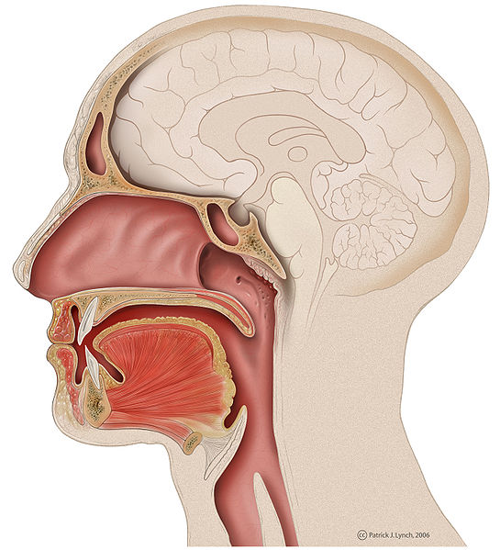
"Head lateral mouth anatomy" by Patrick Lynch -CC:BY
Useful guidance on supporting others to attribute your work correctly can be found at http://creativecommons.org/choose/.

A note on citation and attribution

Guideline 4: Specify how the material is to be cited when other people reuse or adapt it

Guideline 5: Attribute correctly any content objects included in the OER that have been created by someone other than authors
The difference between citation and attribution is explained clearly at https://open.umich.edu/share/cite. In essence, citation is about tracking the intellectual and ideological underpinnings of the work whereas attribution is about crediting a copyright holder according to the terms of a copyright license.
For example,
Sapire, I.(2011). Mathematics for Primary School Teachers. Johannesburg: Saide.
OR
University of the Witwatersrand. (2011). Mathematics for Primary School Teachers. Johannesburg: Saide.
All objects (such as images found on Flickr) should be attributed correctly: you should include the author, the source, and the license.

Third party copyright clearance

Guideline 6: Ensure that permission has been obtained for third party copyrighted material used in the material
Often lecture material contains diagrams, pictures or other objects for which the individual lecturer is responsible, rather than the institution. Since the lecture material is not published, it remains inside the walls of the lecture hall, and does not pose a legal problem.
However, if copyrighted material is to be incorporated into published material/OER on a website, they become the institution’s responsibility – the copyright holder of the OER will be liable for infringements of copyrighted material used.
There are three ways of dealing with this:
- Replacement of the material with other openly licensed material.
- Inclusion of the reference to the material (preferably a web address), without copying the copyrighted material.
- Permission obtained from the copyright holders for digital use of the material on a public website with unrestricted access.
Your institution will have a mechanism for third party copyright clearance as all institutions require clearance for readings used in resource packs or learning guides provided to students. However, they often don’t have experience in asking for permission for use of copyrighted material on a public website.
Guidance for this can be obtained from OER Africa. Please see an explanation of the some of the challenges of getting permission as well as a number of useful tools and templates from OER Africa’s Copyright Toolkit. http://www.oerafrica.org/copyright/Applyingforpermissions/Challenges/tabid/1797/Default.aspxhttp://www.oerafrica.org/copyright/Applyingforpermissions/Toolsandtemplates/tabid/1812/Default.aspx

Ethical clearance

Guideline 7: Prior to the use of photographs and videos containing recognisable people, obtain ethical clearance
Institutions should follow their own processes for ethical clearance for any research they conduct. Particular care should be taken for the correct permissions from the subjects (or caregivers of minor subjects) to be obtained for pictures and videos.

Section Two: File formats
The key issues to consider when deciding on formats are:
- purpose of material (adaptation or mainly downloading and re-use);
- availability of formats (readily available and used among target audience);
- cost (users should not be required to purchase software to use resources).

Selection of file formats

Guideline 8: To facilitate adaptation, use formats for text, images, video and audio that are commonly used and editable
One of the advantages of OER is the open license, which allows duplication and adaptation of the resource. If you distribute files only in non-editable formats like PDF or Shockwave Flash (SWF), you create technical obstacles to adaptation. YouTube and several popular video-editing applications do not accept SWF files. It is best to distribute editable formats so that others are technically able to adapt the materials to their context. Additionally, try to use file formats that are commonly used and avoid proprietary formats if possible.
For text, you could use the office suite most widely used by your target audience, (e.g. if your audience uses Microsoft Office, you might want to use Microsoft supported formats, but you may need to check which version is most common – your target audience may not have access to the latest version), or a free, open source equivalent such as Open Office or Libre Office (ODP, ODF, ODS). HTML also works well across operating systems and works with any Internet browser.
For video, common formats for video include MP4 (H.264), MOV, FLV, and AVI.
For audio there are MP3, FLAC, and WAV.
For images there are JPEG, JPEG 2000, PNG, GIF, SVG, and TIFF. If possible, it also useful to share your available source files for images (e.g. Adobe Photoshop), video clips, or Flash (such as FLA).
If you wish to publish non-editable compressed formats (such as PDF) for convenience of file sizes or embedding in an HTML, it is best to distribute a second copy in an editable or easily adaptable format.

Preparation of files for uploading

Guideline 9: Prepare the material for uploading with a view to ease of downloading, remixing and discoverability
Wherever possible, it is advisable to ‘chunk’ OER into smaller sections, and prepare for separate uploading. Distributing each OER as a single unit makes the title of the individual resource more prominent and therefore easier to find when browsing and searching. However, see under ‘metadata’ for discussion of how to describe ‘these chunks’ in ways that facilitate discoverability. Availability of material in smaller discrete units can also facilitate adaptation – provided that there is a clear sense of how the parts fit into the whole.
The size of the file is also an important consideration. Particularly in low bandwidth situations, files larger than 20 MB take a long time to download, and potential users may be put off by the effort required. There are some who claim that a video loses its effect after 3 minutes – although for some purposes (for example, lesson study) it might be necessary to have a large chunks for students to critically review.
One option for large files is to include high resolution and low resolution versions on the website, with an explanation that for quick view, the low resolution version will be adequate, but for quality, the user will need to find a way to download the much larger file.
Another option for large files is to include scripts of video and audio files as PDFs, so that, if the bandwidth is low, there is another form of access to the material.
In all cases where smaller ‘chunks’ of longer resources are used, care needs to be taken to label the chunk appropriately. For example,
Fig 4: Attribution of ‘chunked’ section of audio
If the OER consists of a number of multimedia elements, it’s advisable to present them as a collection of learning objects, zipped together. Bundling multiple large files like videos into a single package (e.g. embedding resources into an HTML module) can increase file size and cause confusion among learning objectives and scope. By distributing files as separate entities that are part of a collection or series, users will have direct access to the individual components of an OER, whether that is a video, a quiz, or a list of learning objectives. For an example, see http://open.umich.edu/education/med/resources/palliative-care/2010/materials.

It is also a good idea to present the material in different formats, so that users choose how they want to engage with the resource. For example, OpenLearn allows download of its Moodle based units in print format as well as a zipped folder containing all the multimedia assets separately.
Fig 5: Making OER available in different formats (see OpenLearn)
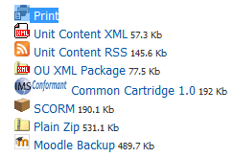
This enables users to access not only to engage with the unit as a whole while offline, but to pull out one or more of the assets (a reading, a video clip, a quiz, a flash animation, etc).

Section Three: Metadata

Guideline 10: When a resource is submitted for uploading, the institution/s should provide the necessary metadata – particularly title, description, and key words
For a detailed overview of metadata please see:
http://www.niso.org/publications/press/UnderstandingMetadata.pdf.
This article describes metadata as:
structured information that describes, explains, locates, or otherwise makes it easier to retrieve, use, or manage an information resource. Metadata is often called data about data or information about information.
Part of the metadata is the information that should appear on the resource itself (see above). But additional information is needed so that, once uploaded, the resource is searchable.
Particularly important in this regard is what is known as the ‘controlled taxonomy’. A taxonomy for a website is a set of categories under which to organise resources when they are uploaded. These categories are the topics under which you can search for resources to meet your needs. It is important for the community that is going to use the resources to have input into the topics.
In addition to a ‘controlled taxonomy’, creators of resources are asked to list key words or ‘tags’. As Wikipedia explains
a tag is a non-hierarchical keyword or term assigned to a piece of information (such as an Internet bookmark, digital image, or computer file). This kind of metadata helps describe an item and allows it to be found again by browsing or searching. Tags are generally chosen informally and personally.’
There are a number of different international metadata system, one of the most common being Dublin Core standard. The following elements from this standard are usually used by OER Africa in uploading resources.
- Title/name of resource
- Description
- Key words (choose the most significant and unique words)
- Topic (from controlled taxonomy)
- Author/s
- Contributor/s
- Publisher
- Copyright holder
- Year
- Resource media type (eg image, video, audio, text)
- Resource format eg JPEG, PDF, Doc (and alternative format available, with relevant file sizes)
- Licensing condition (Creative Commons license for the resource)
- Language (and alternative language available)
- Source (if appropriate – the URL where it resides)
- Federation (Can this resource be federated to other repositories such as Merlot, OER Commons, Global?)
Note: The resource itself stays in the host repository, it is merely the metadata that gets federated to the other repositories and when one opens the resource it opens in the original host repository.
If the resource is a course, it may be desirable to include such fields as level and prior learning required.
All the resources linked to a particular course need to be examined, and decisions taken as to whether they can work as standalone resources or whether they should be an asset of a particular course/unit/resource. For example, there may be a video or audio that makes no sense at all unless it is linked to the course guide or a unit of the course guide – then it should be an asset.
Naming resources is very important.
- If there are different parts to your online resource, the title in the metadata should contain the name of the main part of the resource and then the name of the particular part.
- The resource description (an abstract) should explain the overall purpose of the resource and even better, explain why this resource is being used in a particular context. Ideally, there should be both a short description and a long description. The short description shows in the initial search results and has a limited number of characters – so this also has to be carefully worded to give a brief overview of the resource.
- If the resource has a number of parts the first part of the resource gives the overall purpose and the next part gives a description of that unit.

Section Four: Quality management
To ensure that quality is considered when resources are prepared and uploaded as OER, different people within a design and development process need to take responsibility for different aspects of quality. For example, in a University, approval of courses is the responsibility of Senate, but the individual academic department heads may have the authority to approve the materials to the developed or adapted. There may be a team approach to planning and undertaking the materials development process, with a project leader. But there are also a range of administrative tasks which may be undertaken by library or IT people within the institution.
The following is an illustrative list of tasks that should be delegated ahead of time, with careful planning of timelines. These tasks may not be sequential, but run in parallel. For example, third party copyright clearance may take some time, and therefore, for resources that are definitely needed, this process could start well before the materials are sent for external review, and the final layout and design tasks concluded.
Activity | Responsible | Timeline
For materials development team
- Obtain approval (if necessary) for development of course and/or materials.
- Source existing materials (OER) and conceptualise materials to be developed/adapted.
- Set up materials development team, and plan the materials development/adaptation process.
- Arrange for internal and external critical review.
- Obtain ethical clearance in accordance with the regulations of their own institution.
- Obtain copyright clearance for third party copyrighted materials used.
- Develop/adapt the materials according to the schedule in the materials development plan.
- Lay out, design and copy edit the materials (commissioning the necessary illustrations or multimedia development as appropriate).
- Sign off and submit materials to website management team in the required file formats, with the required covering information / metadata.
For website management team
- Design website to facilitate discoverability by search engines and reciprocal links between this website and other websites sharing similar objectives.
- Check the covering information / metadata is complete and follows the guidelines.
- Check that there is alignment between the materials and the covering information / metadata.
- Check that the Project Manager / Leader / Co-ordinator responsible has signed off the materials.
- Upload the materials onto the website, using the agreed covering information / metadata fields.
- Notify Project / Department / Division of uploading and ask them to check.
- Manage the process of tracking and describing use.

A note on tracking and describing use
To measure and monitor the effectiveness of the website, electronic means to track use should be installed. For example, Google Analytics and AWStats are free web traffic software designed to measure the activity of visitors to a website and break it down into trends. AWStats measures bandwidth, which is the amount of data transferred on the website, and Google Analytics measures website traffic and trends.
However, to complement these strategies, it is recommended that the institution actively solicit information on use and adaptation of the materials from the project / department / division.
This could be facilitated by creating and stimulating use of a feedback form in which those who have used materials from the website are asked to respond to the following questions:
- What search engine did you use to look for the resource?
- What key words did you use to look for the resource?
- What is the title of the resource you used?
- From which institution (and/or geographical region of the world) are you using this resource?
- Are you a: student, lecturer, tutor, researcher, course designer, other? (Please tick one.
- If ‘other’ please tell us what your role is.
- Did you modify, change or adapt the resource? If Yes in what way?
- Did you have any difficulties using the resource? If "Yes", can you tell us about these difficulties?
- How useful was the resource for learning about this subject/topic?
- How would you rate the quality of resource?
- Would you recommend the resource to others?
- Are there any other comments you would like to make about the resource?
(From Leicester OER Toolkit at http://www2.le.ac.uk/departments/beyond-distance-research-alliance/projects/otter/documentation/University%20of%20Leicester%20OER%20Toolkit%20version%2015%20Sept%202010.pdf/view)

Appendix: Workshop Activities on the OER Protocol (13 July 2012, at University of Cape Coast, Ghana)

Activity 1: Introduction
In pairs go through Introduction and highlight key words.

Activity 2: Section One
- Who will own copyright on the materials?
- Which Creative Commons license did you choose, and why?
- Refer to your Food Safety and Quality Standards course materials. How will you expect others to cite your work?
- Describe the mechanism at your institution for third party copyright clearance. How will this need to be adapted for OER?
- What ethical clearance do you need for your course materials Why?

Activity 3: Section Two
- In what format/s will you save the materials in order to upload them as OER?
- Do you think they need to be ‘chunked’? If so, how do you want to chunk them?

Activity 4: Section Three
- Complete the metadata information for your course materials, using the following Submission Template:
- Title/name of resource
- Description
- Key words
- Topic (from controlled taxonomy)
- Author/s
- Contributor/s
- Publisher
- Copyright holder
- Year
- Resource media type (eg image, video, audio, text)
- Resource format (eg JPEG)
- Licensing condition (Creative Commons license for the resource)
- Language
- Source (if appropriate – the URL where it resides)

Activity 5: Section Four
- Consider the institutional responsibilities for Quality Management of OER. For which of these responsibilities is there already a system in place? What needs to be done to ensure the other responsibilities are undertaken?
People responsible for QA in the institution: | Systems already in place: | What needs to be done:
- Conceptualise materials to be developed, and communicate to [project team]
- Plan a materials development process and communicate plan to [project team]
- Arrange for internal critical review and external critical review.
- Obtain ethical clearance in accordance with the regulations of their own institution.
- Obtain copyright clearance for third party copyrighted materials used.
- Design and copy edit materials.
- Sign off and submit their materials to [project team] in the required file formats, with the required covering information.
- Who will be the OER publishing team at your institution? Which responsibilities are they already able to undertake? What needs to be done to assist the publishing team to meet their other responsibilities?
Publishing team: | Already able to do: | Need assistance with: | What needs to be done?
- Check the covering information is complete and follows the guidelines.
- Check that there is alignment between the materials and the covering information.
- Check that the Dean/Head of School responsible has signed off the materials.
- Upload the materials onto the website, using the agreed metadata fields.
- Notify institution of uploading and ask them to check.
- Manage the process of tracking and describing use.

A source file enables the adaptation of the resource. Raw source files may be over the file size limit, which is fine, as only a smaller group will be interested in them. One way to share source files is to distribute a second file with all the assets or source files alongside the final resource.
An asset is a distinct resource which can either stand alone or be part of a larger resource.
For a much fuller treatment of course design and materials development, please see Saide’s Design Guide Toolkit (forthcoming) at www.saide.org.za

