The African Storybook Project

A Special Initiative funded by Comic Relief: 2013 to 2016

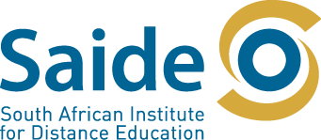
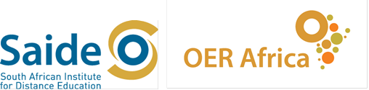
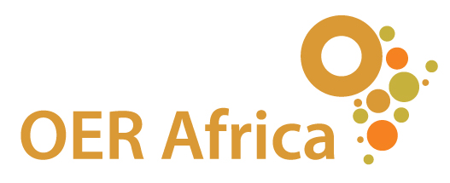

South African Institute for Distance Education
P O Box 31822
Braamfontein
2017
South Africa
Tel: +27 11 403 2813
Fax: +27 11 403 2814
http://www.saide.org.za
http://www.oerafrica.org

© South African Institute for Distance Education

What is the need?
Extensive research shows that the reading literacy levels of African children after the first three years of schooling are far from adequate, both in the basic ability to read as well as the literacy necessary to proceed to the next level of schooling. The achievement of the goals of Education For All are compromised not only by the shortfall in the numbers of children in schools, but also by the quality of the schooling they receive.
In order to ensure that early readers attach to reading and that reading becomes a social practice in schools, communities and homes, three key groups of people need to work together:
- Parents need to be empowered to take an active role in their children’s literacy development from well before the child starts school.
- Communities need to work towards making reading a social practice in the language/s of the community.
- Teachers need to understand not only how to teach reading in a sequenced way, but also provide sufficient reading practice and the opportunity of reading for enjoyment as well as learning.
All the above is impossible without sufficient local /familiar /home language reading material for young children to use for practice. But there is a drastic shortage of appropriate local African language stories for early literacy development for African children. Many of the books that do exist are expensive and difficult to distribute. They are usually funded for a while, and then go out of print, no longer accessible to the children for whom they were intended.

How will the African Storybook Project help to meet the need?
The African Storybook Project will be a digital library with a difference.
To construct the library, we will draw on African oral literature and traditions of storytelling, on high quality published stories that the copyright holders are willing to donate, on openly licensed material already available on the Web, and on stories developed through workshops and competitions specifically for the project.
We will make stories for the first few years of reading available
- in digital formats
- openly licensed
- with a process and tools for translating and versioning stories for local African languages and contexts.
This will enable users are able to upload and share versions of the stories in their local languages, providing numbers of stories in a range of languages way beyond the scope of conventional publishing.
But a digital library is not enough. Much material is available on the Web that is not known about or used, particularly by large numbers of African parents, teachers and children who most need it.
So we will work very hard to get the stories out to people – in different formats, and through collaborative relationships with those already working in the field. We will develop partnerships with literacy development organisations across the continent (but particularly in Uganda, Kenya and South Africa) to use the stories and the website in their project, contributing both lessons of experience to improve the website, and stories or versions of stories.

Our vision
- A vibrant growing network of African teachers, parents and communities access, use, share, and adapt/translate digital versions of openly licensed stories.
- Instead of relying only on publishers to provide stories in local languages for reading practice, they are active participants in finding and creating enough stories for all African children to use for literacy development in homes, communities and schools.
- Governments across Africa recognise that openly licensed digital storybooks can be a cost effective way to provide sufficient appropriate books to support bilingual literacy development in schools, and find country specific ways of developing, versioning, distributing, and using such material.

Who will be involved?
The project is being directed from the Saide offices in Braamfontein.
Although the official start date of the project is 2013, web developers from NBA and associates have already started work on the development of the website, which should take about 18 months to test and refine.
Judith Baker and the central team at Saide have already been engaged in establishing partnerships with a wide range of African literacy development organisations/projects, as well as appropriate technology initiatives, research organisations and libraries. Each partnership will be defined through a Memorandum of Understanding, which will give expression to mutual benefits and contributions.
The central team at Saide will be responsible for ensuring that a critical mass of good stories is available for versioning and use. This will involve getting the necessary permissions, and preparing material for digital uploading. It will also involve shaping good stories for the level and interests of young African children, and ensuring that they are illustrated in lively ways.
In country coordinators will be appointed in Uganda, Kenya and South Africa to manage, for their particular countries:
- Testing and refining the website, versioning tools, and technological models of story delivery for a variety of rural and urban homes, schools/ECD centres and communities;
- Story development in local communities;
- Evaluation of use of the stories to support literacy development;
- Developing strategies for integration of the project into existing literacy development initiatives, particularly in the public education system.

How can you be involved?

Types of stories we’re interested in
Our main interest is stories that children themselves can read themselves when they’re in the first stages of reading – a few words or sentence a page, with an accompanying illustration - although there is a place for more difficult read aloud stories as well.
We’re looking for African stories in languages spoken in Africa that will appeal to African children up to the age of 9 or 10.
If you have a good idea for story, but don’t have an illustration, we may be able to help you.
You can send us typed up stories, or scanned PDF stories with illustrations, or recordings of stories, songs and games.
On the next page is the information that we’d like you to submit with the stories.

For further information
Please contact one or more of the following African Storybook Project team if you are interested to learn more or to contribute:
Judith Baker (partner development) - judithbakr@gmail.com
Sheila Drew (use of the stories in ECD contexts) – sheilad@saide.org.za
Jenny Louw (libraries and knowledge management) - jennyl@saide.org.za
Ephraim Mhlanga (research) - ephraimm@saide.org.za
Rebecca Pursell-Gotz (evaluation research) - rebeccap@saide.org.za
Monge Tlaka (website) - mongetlaka@nba.co.za
Tessa Welch (project leader) - tessaw@saide.org.za

Information to submit with a story
Language of story
Title of story
Author/s
Illustrator
Publisher, place, date
OR
Website address, date
OR
Place and date (if not published)
6. Please provide literal translation of story into English – page by page.
Or, if the story is a long one, a summary.

Type of story (tick one or more of following)  The material needs to be suitable for children up to the age of 9 or 10 | Counting or alphabet book
 | Picture story (wordless book)
 | Story with a sentence per page
 | Read aloud story
 | Riddles, proverbs, tongue twisters, games, songs
 | Child created/illustrated story
 | Non-fiction
 | Folk tale
 | Other (describe)

