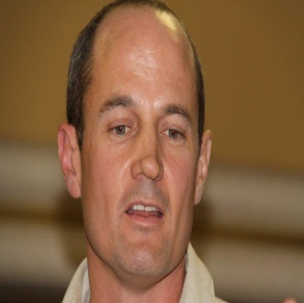
NEIL BUTCHER is based in South Africa, from where he has provided policy and technical advice and support to a range of national and international clients regarding educational planning, uses of educational technology and distance education, both as a full-time employee at the South African Institute for Distance Education (SAIDE) from 1993 to 2001 and as Director of Neil Butcher & Associates since then. He has worked with various educational institutions (including UNESCO and the Commonwealth of Learning), assisting with transformation efforts that focus on effectively harnessing the potential of distance education methods, educational technology, and OER.
Neil has travelled extensively through the developing world conducting research on educational policy, higher education, distance education, and educational technology for a range of organizations, governments, and donors. He works with OER Africa as the project’s OER Strategist, and is supporting South Africa’s Council for Higher Education in revising its organizational processes and structures. He is also currently consulting to the World Bank on a range of project activities in India, including a large-scale Teacher Effectiveness Programme in Bihar.

